Project Initialization and Planning Phase

Date | 06 July 2026
Team ID | SWTID-2026-1392
Project Name | Credit Card Approval Prediction
Maximum Marks | 3 Marks

Define Problem Statements:

Customers often face delays and uncertainty during the credit card application process due to manual verification and lengthy approval procedures. Financial institutions also spend significant time screening applications manually. There is a need for a fast, accurate, and transparent system to assess credit card eligibility. The proposed machine learning-based solution predicts approval instantly using applicant details. This improves customer experience while reducing processing time and operational effort for banks.
Example:
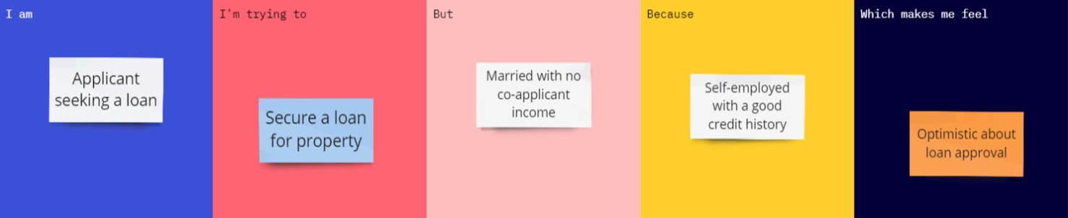
Anxious about wasting an application, but hopeful for an instant answer
I don't want to apply formally and get a hard rejection on my credit record
Unsure if my income and education details are actually enough to qualify
Get quick clarity on my card approval chances
Applicant seeking a credit card

Problem  Statement  (PS) | I am (Customer) | I’m trying  to | But | Because | Which makes me feel
PS-1 | An applicant applying for a credit card | Get quick clarity on whether my application will be approvedq | I have to wait days for a manual decision with no visibility into the outcome | The bank's approval process depends on internal criteria I can't see upfront | Anxious and uncertain about whether to plan around having the card
PS-2 | A working professional with a modest, steady income | Understand how factors like my income type and education affect my approval odds | Traditional forms give a flat yes/no with no explanation of what influenced it | The underlying decision criteria are opaque to applicants | Frustrated, since I can't tell what to improve if I'm rejected
PS-3 | A bank/credit officer reviewing applications | Screen a high volume of applications quickly and consistently | Manual review is slow and prone to inconsistent human judgment | Each application must be checked against income, income type, and education criteria | Overwhelmed by repetitive manual assessments that could be automated

